Dynamic Modeling Of Northern New York Renewable Energy Sources
Josie Colaccico and Frank Parsons, NSF REU Scholars
Department of Electrical and Computer Engineering, Clarkson University, Potsdam, NY, United States

Abstract—A dynamic model of the Northern New York power grid was built using MATLAB Simulink to investigate the potential for control interactions between these generation sources in the North Country and the downstate power grid. The North Country grid primarily consists of wind farms totaling 678.45 MW and the 912 MW St. Lawrence-FDR hydro power plant in Massena, New York. The infrastructure connecting these sources includes the new 345kV transmission lines as well as a 765kV transmission line linked with the power grid in Quebec. Tests were conducted to evaluate grid reliability and potential for power transfer. Faults were placed at various locations in the network and tested for varying durations.
Index Terms--wind, hydro, Northern New York, renewable energy, reliability, dynamic

Introduction
As of 2023, New York State has initiated a plan to achieve a power grid that is 70 percent renewable by 2030 [1]. In order to achieve this goal, they are relying heavily on Northern New York which has significant hydroelectric and wind generation [2]. These renewable sources supply the New York power grid with instabilities, as perfect conditions cannot be secured for their operation [3]. Additionally, due to the relatively small load in Upstate New York there is a large export of power to southern New York [4]. The New York State Power Authority (NYPA) is currently in the process of upgrading the transmission infrastructure to accommodate the addition of new renewable sources and a heavier downstate load [5]. With the added complexity from the renewable sources and new transmission infrastructure, effective modeling is needed to understand potential vulnerabilities in the system. MATLAB Simulink was chosen to develop the model due to its easy to use block format which provides fast tuning of system parameters. The two most critical components of the grid model are six wind farms located near Chateaugay, NY and the St. Lawrence-FDR Power Project hydroelectric dam in Massena, NY as they represent the largest renewable generation in the Northern New York power grid [6]. Another significant component of the North Country grid is the high voltage direct current (HVDC) converter in Chateauguay, Quebec. Northern New York receives a significant import of power from Quebec through this connection [7]. This research presents a MATLAB/Simulink analysis of the Northern New York renewable energy grid. A dynamic model was created in order to observe instabilities and the response of the grid to any failures.

Methods
In order to quickly develop an overall model of the Northern New York power grid, a set of pre-existing Simulink models for the hydro, wind and HVDC converter were combined together. The HVDC converter and wind farm models were designed by researchers at the Canadian utility Hydro-Québec. The main wind farm model used was the Synchronous Generator and Full Scale Converter (Type 4) Average Model shown in figure 1 below [8]. This design includes a number of useful features which enable customization of the model for different wind turbine models. The core component of this model is the synchronous generator which is driven by turbine and drive train control blocks. A DC-DC Boost Converter Average Model steps up the synchronous generator voltage. An average model is utilized which approximates the power electronic components and thus improves simulation performance. An inverter and filter process the boosted DC voltage to AC output on the grid. Within the grid control block, there are voltage and current regulators with gains that can be tuned to enhance system performance.
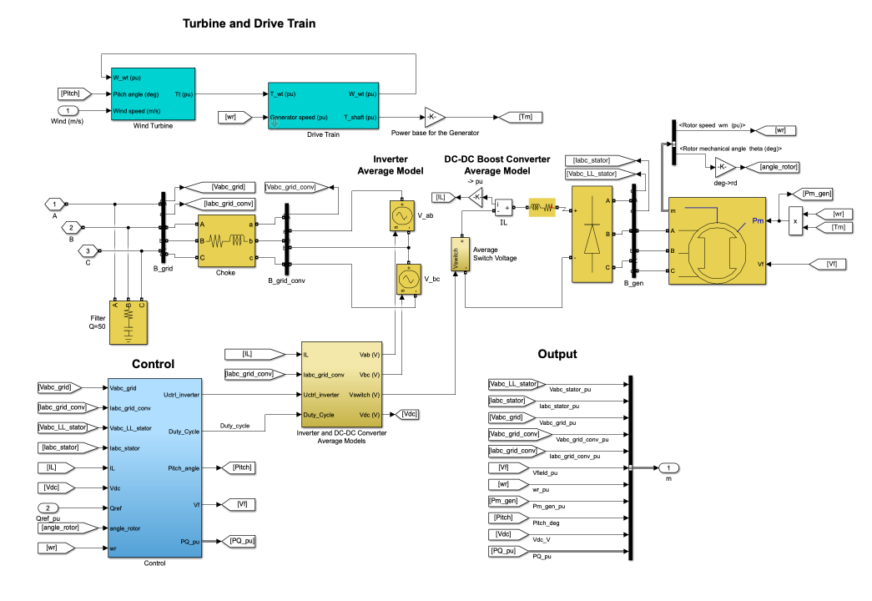
Figure 1 Hydro-Québec Type IV Wind Farm Simulink Model
To decide which wind farms to model, a 2024 map provided by the New York Independent System Operator (NYISO) shown in figure 2 below was used [9]. Six wind farms totalling 678.45 MW near Chateaugay, NY were selected due to their large capacity and influence over the North Country grid. Next, the United State Geological Survey (USGS) Wind Energy database was used to identify the number of turbines and capacity of each farm [10].
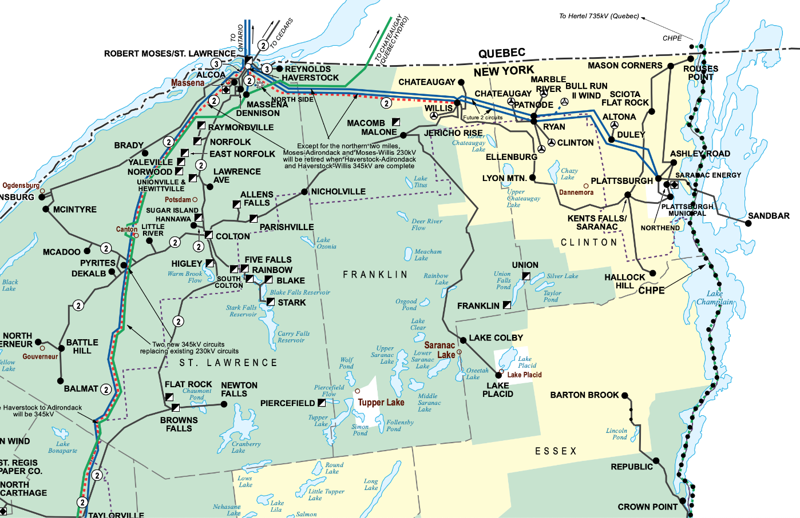
Figure 2 North Country Section of 2024 NYISO New Electric State Electric System Map
In table 1 below, the specifications for each wind farm are listed from the USGS database. The Hydro-Québec model from figure 1 was copied five times for the Type IV wind farms. The nominal power and voltage were changed to match the specifications.
Table 1 Data for Six North Country Wind Farms from USGS Database
Project Name | Turbine Model | Number of Turbines | Turbine Capacity (MW) | Total Capacity (MW) | Turbine Type
Jericho Rise | G114-2.1 | 37 | 2.1 | 77.7 | Type III (DFIG)
Marble River | V112-3.075 | 70 | 3.075 | 215.25 | Type IV (DFAG)
Noble Altona | GE1.5-77 | 65 | 1.5 | 97.5 | Type IV (DFAG)
Noble Chateaugay | GE1.5-77 | 71 | 1.5 | 106.5 | Type IV (DFAG)
Noble Clinton | GE1.5-77 | 67 | 1.5 | 100.5 | Type IV (DFAG)
Noble Ellenburg | GE1.5-77 | 54 | 1.5 | 81 | Type IV (DFAG)
While five of the wind farms are Type IV, Jericho Rise is Type III. For this reason, another model was needed; an induction generator instead of a synchronous one. A similar model shown in figure 3 below from Hydro-Québec was used: Wind Farm - Doubly Fed Induction Generator [11]
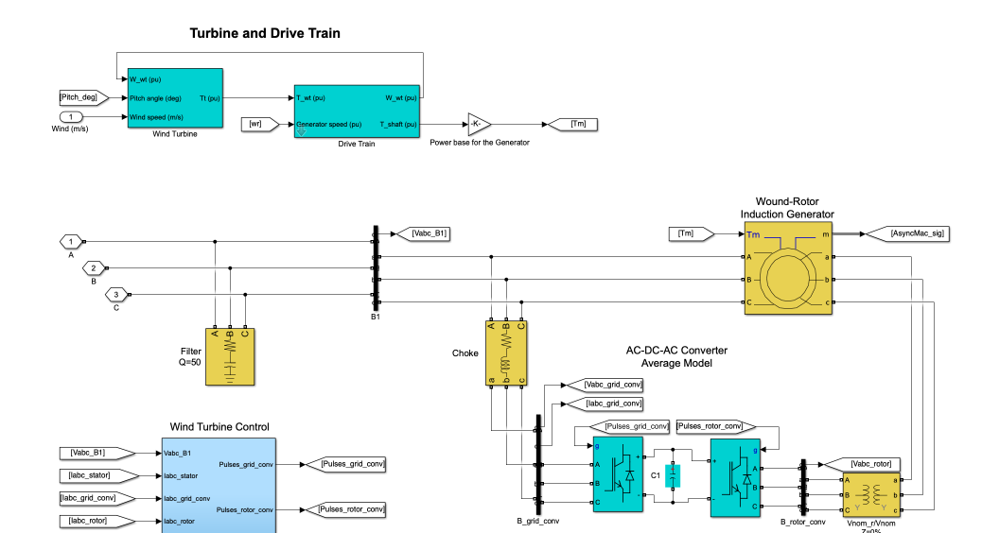
Figure 3 Hydro-Québec Type III Wind Farm Simulink Model
Contained within each wind farm subsystem block are the appropriate transformers to interface with the grid. The first transformer steps the voltage of the turbines (690V) to the collector system voltage of 34.5 kV. The collector line for each wind farm is 1 km which represents an average value of the individual collector lengths. The specific collector line lengths for each turbine could not be modeled as the information was not publicly available. To step the collector voltage to the grid voltage, a 34.5 kV to 345 kV transformer was used. In the case of the Jericho Rise wind farm (type III) an additional transformer was needed, going from 34.5 kV to 115kV before going from 115 kV to 345 kV. For all the transformers, the per unit resistance was increased from 0.002 to 0.0125 and the per unit inductance was decreased from 0.08 to 0.025. While the actual values for the transformers are confidential, these values were chosen to create a more realistic model. For all the wind farm transformers, the base power rating was set to 400 MVA. The largest wind farm (Marble River) is 215.25 MW, so this rating leaves a reasonable safety factor even for the largest wind farm. Figure 4 below shows the distribution infrastructure connected to each wind farm.
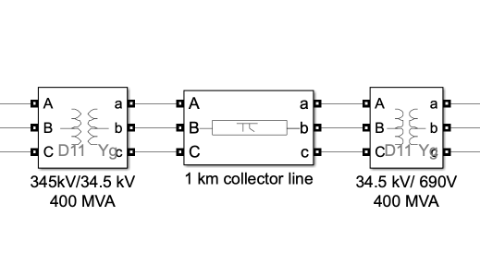
Figure 4 Transformer Configuration for Type IV Wind Farms
The St. Lawrence-FDR Power Project hydro dam was more challenging to model as Hydro-Québec did not have an existing model to use. Instead research from Shewit Tsegaye and Kinde a Fante provided an example hydro turbine model in Simulink [12]. This model makes use of the hydraulic turbine and governor control block and a DC excitation system. The values used in the control and excitation blocks were left at the default values as they perform well in the overall grid model. However, the parameters within the synchronous machine, specifically the time constants and inertia coefficient were increased to provide a more damped response. The hydro dam on the U.S. side has a total of 16 generators, each 57 MW for a total 912 MW [13]. To establish a balance between ease of simulation and accurate modeling, the 16 turbines were divided into two groups of 8 with a complete governor and excitation system for each set of 8. Figure 5 below shows the final model used for the hydro dam. To interface the hydro dam with the grid, a transformer from 13.8 kV to 345 kV was used with a rating of 1000 MVA. 13.8 kV was chosen based on the typical generator output voltage for a hydro generator of this size. The 1000 MVA rating is slightly above the max power output of 912 MW. Since the hydro dam is unlikely to produce at this maximum output, 1000 MVA offers enough headroom for this transformer.
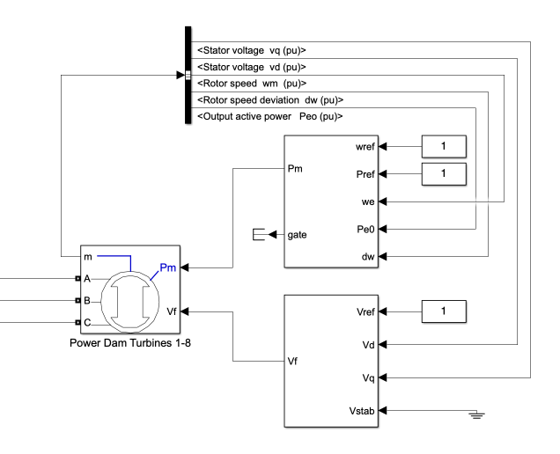
Figure 5 Simulink Model used for St. Lawrence-FDR Power Project Hydro Dam based on research by Shewit Tsegaye and Kinde a Fante
The model used for the HVDC converter is called Thyristor Based HVDC Transmission System [14]. It consists of an inverter, DC lines, a rectifier, and filters. The HVDC converter in Chateauguay, Quebec is back-to-back, meaning there are very short DC connections between the inverter and rectifier. For this reason, the DC line in the Simulink model was removed. Figure 6 below shows the original model with the DC line included.
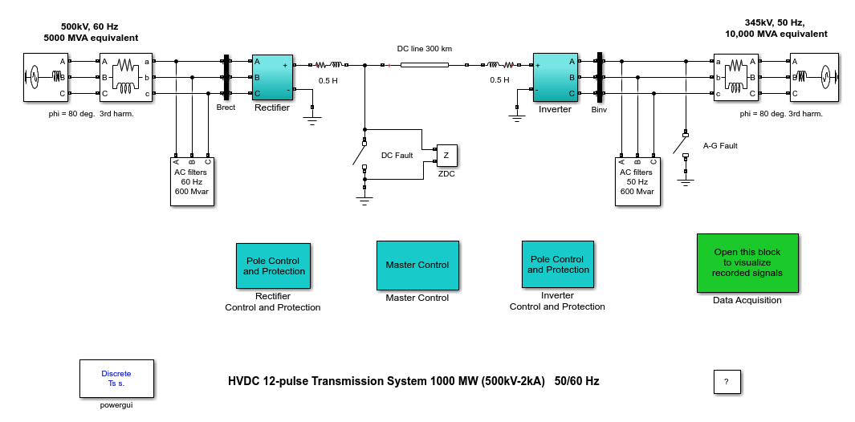
Figure 6 Hydro-Québec Thyristor Based HVDC Simulink Model
In order to connect each component to form the overall grid, the three phase pi section block was used to model transmission line resistance, inductance and capacitance. Due to the lack of publicly available information, data from a 2019 New York synthetic power grid model was utilized [15]. Developed by University of Wisconsin-Madison, this model contains per unit resistance, reactance and susceptance for each transmission line in New York State. Since NYPA is in the process of upgrading the North Country 230 kV lines to 345 kV, the current 230 kV synthetic values were not used. Instead, a comparable 345kV line was used with a resistance, reactance and susceptance of 0.0023, 0.03627, 0.93764. Since the Simulink pi sections require the specifications in the form of Ω/km, H/km and F/km, conversions needed to be made before adding to the model. First, using a power base of 100 MVA and 345 kV, the impedance base was found, then the per unit values were converted to total impedance. Total inductance and capacitance were calculated based on a frequency of 60 Hz. Finally, the total values were divided by the total line length of 62.1 mi (99.94 km). In equations 1, 2, and 3 below, the resistance, inductance and capacitance of the line are computed.
$R=\frac{ 0.00238 pu * \frac{(345kV)^{2}}{100 MVA} }{62.1 mi * 1.609 km/mi }= 0.283 Ω/km$ (1)

$L =\frac{\frac{ 0.03627 pu * \frac{(345kV)^{2}}{100 MVA}}{2π * 60}}{62.1 mi * 1.609 km/mi }= 1.146 mH/km$ (2)

$C =\frac{\frac{1}{(0.93764 pu * \frac{(345kV)^{2}}{100 MVA})*2π * 60}}{62.1 mi * 1.609 km/mi}= 20.9 nF/km$ (3)

A similar process was repeated for the 765kV transmission lines connecting the 345 kV network to the HVDC converter in Quebec. The per unit resistance, reactance and susceptance from the 2019 synthetic data for this line are: 0.00039, 0.01191, and 5.78152. The total line length is 121.7 mi (195.85 km), making the final values for the pi section: 0.0117 Ω/km, 0.944 mH/km and 4 nF/km.
These calculated values for the 345kV and 765kV lines were used for all sections. Each section length was determined using an ArcGIS database of U.S. Electric Power Lines [16]. The database map includes a measurement feature (shown in figure 7) which allows for individual measurement of each section.
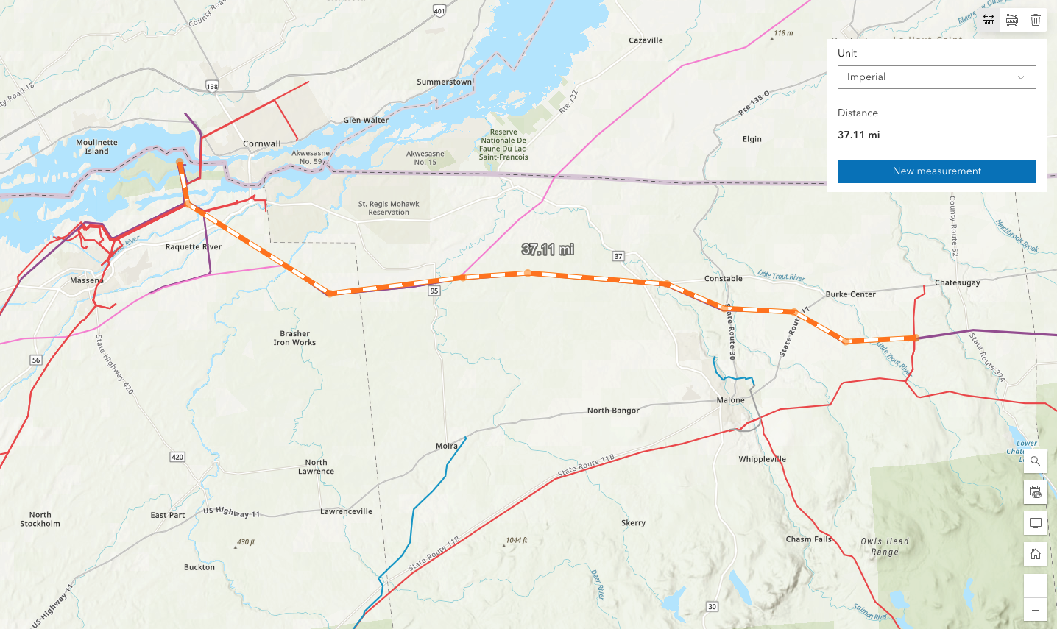
Figure 7 ArcGIS Database Map
After determining the individual section lengths, they were added to the model. Using another map tool called the Open Infrastructure Database, the main substations and line configurations were identified [17]. For most of the 345 kV length, there are two sets of lines. Based on the map data, Marble River and Noble Altona are connected to one set and Jericho Rise, Noble Chateauguay, Noble Clinton and Noble Ellenburg are connected to the other set. At each substation, breaker blocks were added, enabling the disconnection of each section of line. Additionally, a bus tie breaker was added to connect the two line sets together. These breakers were later utilized during fault testing. Figure 8 below shows the breaker setup at each substation and figure 9 shows the overall connection of each component in the model.

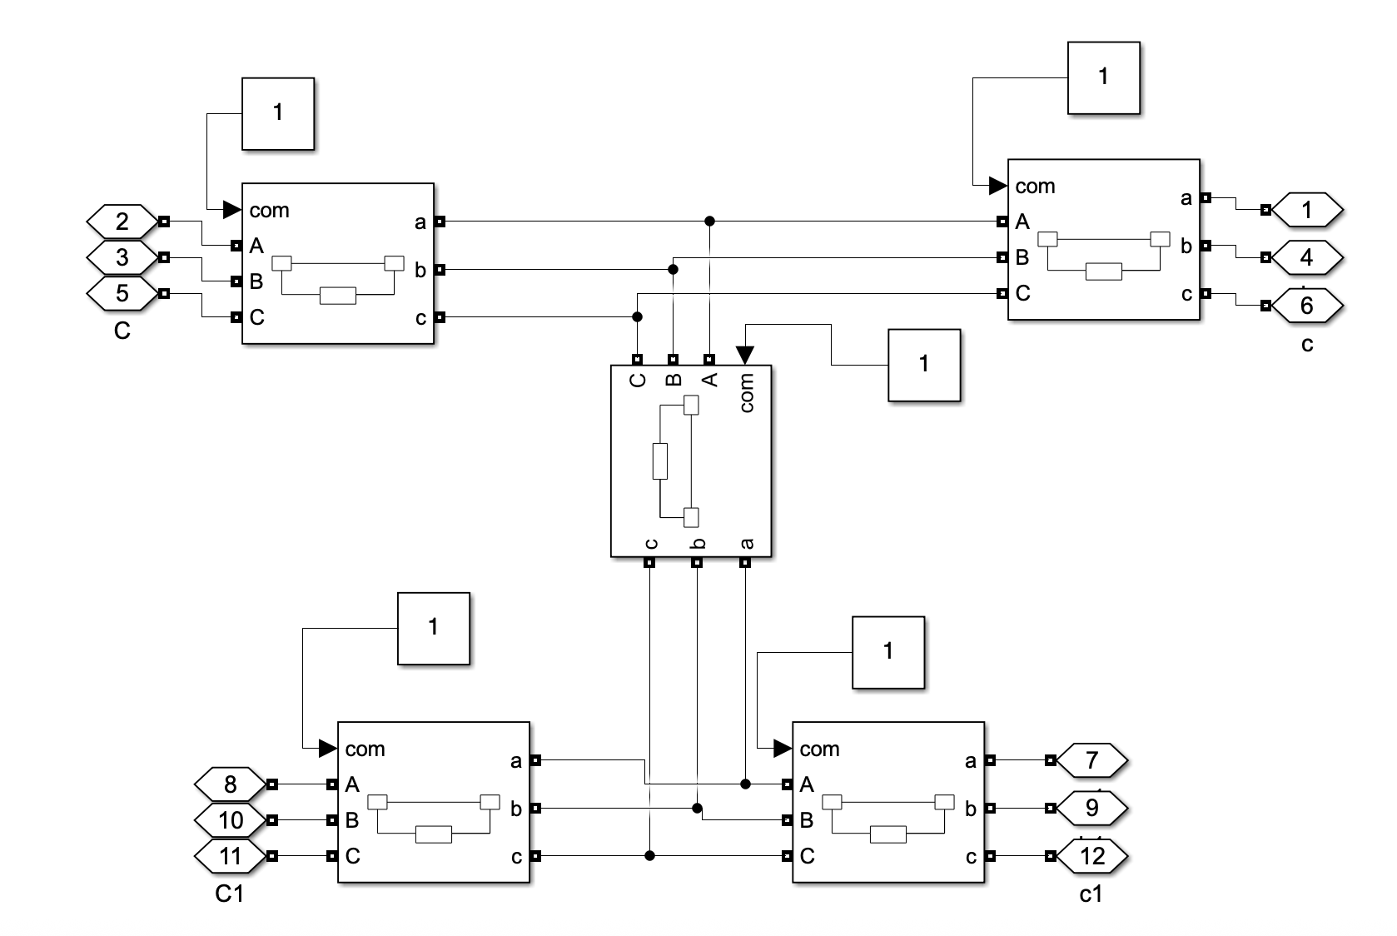
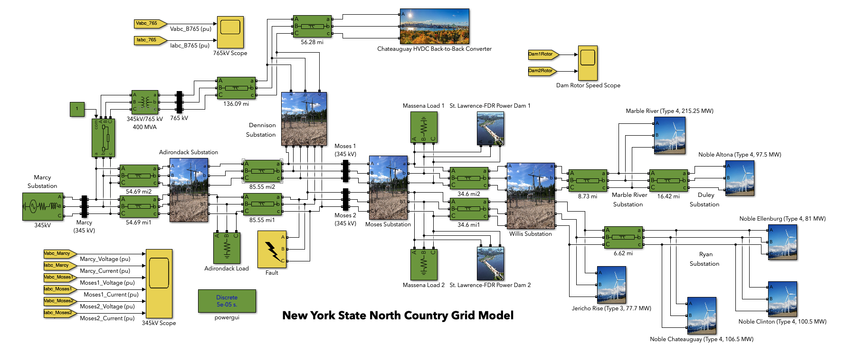
Figure 8 Substation Breaker Configuration
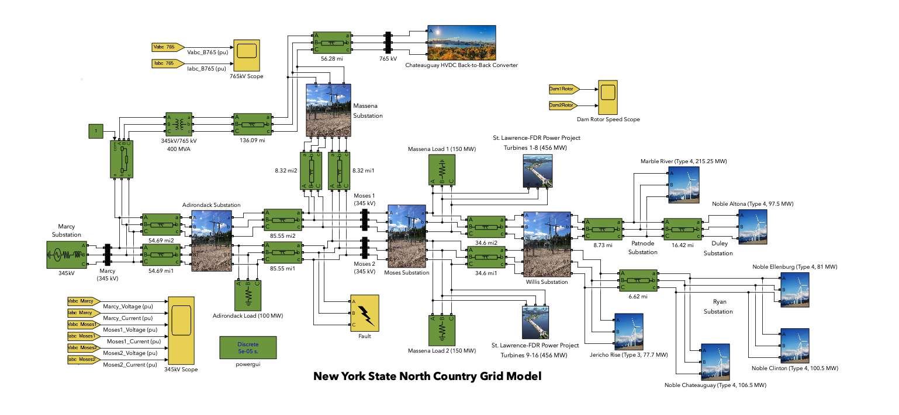
Figure 9 Overall Simulink Model
To simulate loads on the grid, a set of three-phase parallel resistive loads were added at appropriate locations in the model. Two of these loads were added near the Moses substation which represents the load of Massena, NY and the surrounding area. A total value of 300 MW was selected based on the reported energy consumption for the area. Source to add here? It was then divided by two to be distributed on each set of 345 kV lines. For the load farther to the south, a resistive load of 100 MW was added at the Adirondack substation. Like with Massena, NY this value is based on an approximation of the area's energy consumption. Source to add here? The final component to add to the model was the infinite voltage source and load at Marcy substation. Since the model only includes the North Country grid, this substation was selected as the location to stop modelling. The infinite bus provides a convenient simplification of the downstate grid. Default values of 0.8929 Ω and 16.58 mH were used for the impedance.
Fault testing of the dynamic model was conducted to determine the response of the renewable grid to undesirable conditions. The Simulink three-phase fault block was added to the model. In order to test the worst case fault scenario, a full three-phase fault to ground was tested. The total duration was varied between 6 to 24 cycles (0.1 to 0.4 seconds) and was triggered after the model had reached steady state. Additionally, the location of the fault was varied. Add more about fault testing

Results

Conclusion

Acknowledgments
NSF Award #2150238: “Resilient Carbon-Free US Electric Power Systems”

References
[1] New York State Energy Research & Development, “New York’s Commitment to Clean Energy,” NYSERDA. [Online]. Available: https://www.nyserda.ny.gov/All-Programs/Large-Scale-Renewables/Tier-Four/About-Tier-4
[2] New York State Energy Research & Development, “America’s Largest-Ever Investment in Renewable Energy is Moving Forward in New York,” NYSERDA. [Online]. Available: https://www.nyserda.ny.gov/About/Newsroom/2023-Announcements/2023-10-24-Governor-Hochul-Announces-Nations-Largest-Ever-State-Investment
[3] New York State Reliability Council, “The Impacts of High Intermittent Renewable Resources On the Installed Reserve Margin for New York,” [Online]. Available: https://www.nysrc.org/wp-content/uploads/2023/05/AI-5-High-Intermittent-Renewable-Resources-White-Paper.pdf
[4] U.S. Energy Information Administration, “New York - State Profile and Energy Estimates.” [Online]. Available: https://www.eia.gov/state/analysis.php?sid=NY#41
[5] “Governor Hochul Announces Completion of North Country’s Smart Path 78-Mile Clean Energy Transmission Project | Governor Kathy Hochul.” [Online]. Available: https://www.governor.ny.gov/news/governor-hochul-announces-completion-north-countrys-smart-path-78-mile-clean-energy
[6] U.S. Energy Information Administration, “Renewable Electricity Infrastructure and Resources Dashboard.” [Online]. Available: https://eia.maps.arcgis.com/apps/dashboards/77cde239acfb494b81a00e927574e430
[7] Hydro-Québec, “Exports to New York.” Accessed: Jul. 18, 2025. [Online]. Available: https://www.hydroquebec.com/clean-energy-provider/markets/new-york.html
[8] Richard Gagnon and Jacques Brochu, “Wind Farm - Synchronous Generator and Full Scale Converter (Type 4) Average Model.” [Online]. Available: https://www.mathworks.com/help/releases/R2024b/sps/ug/wind-farm-synchronous-generator-and-full-scale-converter-type-4-average-model.html
[9] New York Independent System Operator, “New York State Electric System Map.” [Online]. Available: https://www.nyiso.com/documents/20142/41164815/07_08_NYS_Electric_System_Map_2023.pdf/558a0743-421a-c544-f972-75283155ef00
[10] United States Geological Survey, “U.S. Wind Energy Database,” USGS. [Online]. Available: https://energy.usgs.gov/uswtdb/
[11] Richard Gagnon, “Wind Farm - Doubly-Fed Induction Generator (DFIG).” [Online]. Available: https://www.mathworks.com/help/sps/ug/wind-farm-dfig-detailed-model.html

[12] Shewit Tsegaye and Belachew Banteyrga, “Hydro governor control of synchronous machines: MATLAB/SIMULINK based analysis,” 2018, doi: 10.13140/RG.2.2.14595.60961/1.
[13] International Lake Ontario-St. Lawrence River Board, “Lake St. Lawrence,” International Joint Commission. [Online]. Available: https://www.ijc.org/en/loslrb/lake-st-lawrence
[14] Silvano Casoria, “Thyristor-Based HVDC Transmission System.” [Online]. Available: https://www.mathworks.com/help/sps/ug/thyristor-based-hvdc-transmission-system-detailed-model.html
[15] University of Wisconsin-Madison, “University of Wisconsin-Madison PERFORM Cases,” Electric Grid Test Case Repository. [Online]. Available: https://electricgrids.engr.tamu.edu/university-of-wisconsin-madison-perform-cases/
[16] Federal User Community, “U.S. Electric Power Tranmission Lines,” ArcGIS. [Online]. Available: https://www.arcgis.com/apps/mapviewer/index.html?layers=d4090758322c4d32a4cd002ffaa0aa12
[17] Russ Garrett, “Open Infrastructure Map.” Accessed: Jul. 18, 2025. [Online]. Available: https://openinframap.org

